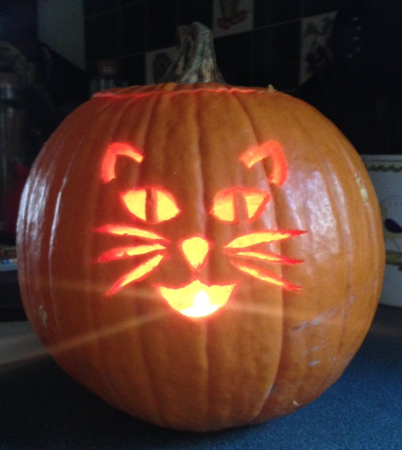
COUNTRY CHILDRENS CENTER
annual Family fall festival
Saturday, October 27
11—2
At the Ccc “Farm”

466 Cross River Rd
Katonah

$20
Per family

FOOD
MUSIC
Pony Rides (11-12)
HOMEMADE DOUGHNUTS
Bounce House
ENCHANTED WOODS
PUMPKIN PATCH
PHOTO BOOTH …and more

(Shuttle service available from CCC White House for overflow parking)
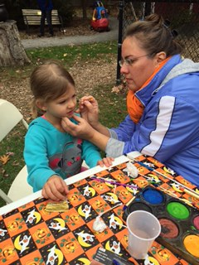

(Rain date Sunday Oct 28)

